Premises Name: _______________________________
Premises ID (PIN): Address:_____________________________________

Establish the Line of Separation (LOS) and LOS Access Point: Standard Operating Procedure (SOP)

Example SOP – Modify to fit your operation

Line of Separation (LOS)
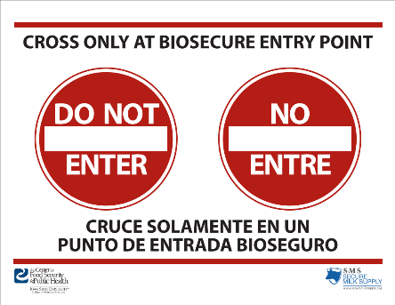
- Refer to the aerial map of the operation in the biosecurity plan to determine where the LOS needs to be marked
- Establish barriers (gate/rope/tape/chains/DESCRIBE) to prevent off-farm traffic from entering the operation
- Establish additional barriers (rope/tape/chains/DESCRIBE) on either side of the LOS Access Point(s) to prevent vehicles/equipment/people from driving around the barriers
  - Hang sign on barrier (Cross Only at Biosecure Entry Point) which can be found in the [office, feed mill, DESCRIBE]
- Establish a designated parking area for vehicles that will NOT cross the LOS
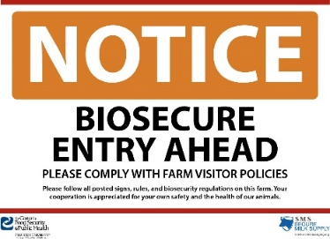
Access Point: Vehicle Entry
- Refer to the aerial map of the operation for the designated LOS Access Point(s) for vehicles and equipment
- Hang a sign (NOTICE: Biosecure Entry Ahead) on the barrier(s) designating the LOS Access Point(s)
  - Sign can be found in the [office, feed mill, DESCRIBE] or printed from: http://hawk.cfsph.iastate.edu/milk-producers/signs-and-posters/
- Set up C&D wash station at LOS Access Point as described in another SOP.

Access Point: People Entry
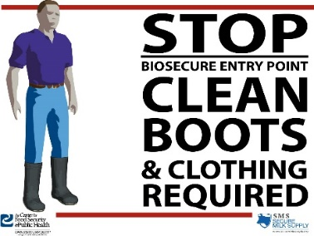
- Establish the [building/door/house/DESCRIBE] to enter the operation as the Biosecure Entry
- Hang signs guiding personnel to designated entrance (NOTICE Biosecure Entry Ahead)
- Establish a clearly marked line of separation establishing off-farm from on-farm using [tape/bench(es)/DESCRIBE] and a place to change footwear, clothing
- Hang a sign (STOP Biosecure Entry Point) on the designated people access point
- Refer to the People Entry/Exit SOP for biosecure entry procedures

