MILK COLLECTION – Truck crosses LOS, HAULER ENTERS MILK HOUSE

Example SOP – Modify to fit your operation
- Hauler must arrive at the farm in clean clothes and footwear that have not been worn around livestock (cattle, pigs, sheep, goats)
- Vehicle cab must be clean and free of visible contamination (no trash, no mud, no manure)
- No other passengers or animals are allowed in the cab of the vehicle
- Before exiting cab, milk hauler must put on clean boots and clean gloves
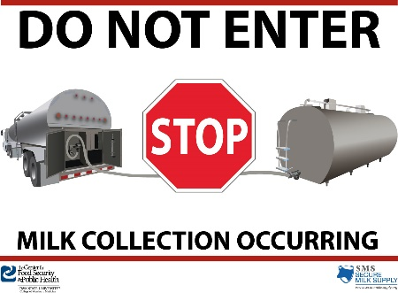
- Milk hauler enters milk house and switches signs on glass doors to: Do Not Enter: Milk Collection Occurring (English and Spanish)
- The milk hauler collects milk samples, labels them, places them in a sealed plastic bag, and sprays the exterior of the bag with citric acid.
  - The bagged samples are placed in the cooler on the truck in the storage compartment.
- Using the truck-mounted transfer hose, milk is pumped from each bulk tank to the truck following normal protocols
- Close inlet valve on the tanker after pumping is complete while hose is still connected.
- Disconnect the hose from the bulk tank in the milk house.
- Drain as much milk as possible from the hose into the milk house drain by “walking the hose back” from the tanker.
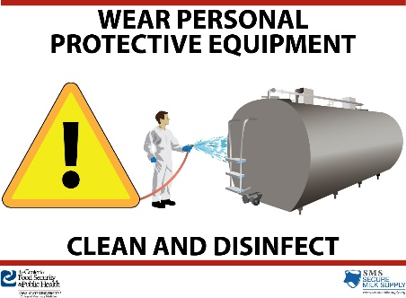
- Cap the hose on both ends.
- Rinse the exterior of hose with water to remove visible organic matter and store in compartment on tanker.
- Water wash boots to remove visible contamination.
- Switch signs on glass doors to: Wear Personal Protective Equipment; Clean and Disinfect (English and Spanish) and leave milk house
- Seal all openings on tanker.
- Hauler returns to cab area, avoid stepping in contamination
  - Farm personnel should be on hand to spray disinfectant on hauler’s clean boots prior to cab entry
  - Hauler climbs steps, opens door, sits on seat and removes boots and gloves prior to closing cab door.
  - Gloves are given to farm personnel for disposal on farm.

EMPLOYEES C&D MILK HOUSE AFTER HAULER LEAVES
- Before entering milk house, put on gloves
- Put on waterproof protective outerwear over farm clothing (pant legs should go over the boots, but not touch the ground)
- Put on safety glasses/goggles
- Put on protective footwear that will not be worn around animals
- Enter milk house and hose down areas where hauler walked/touched
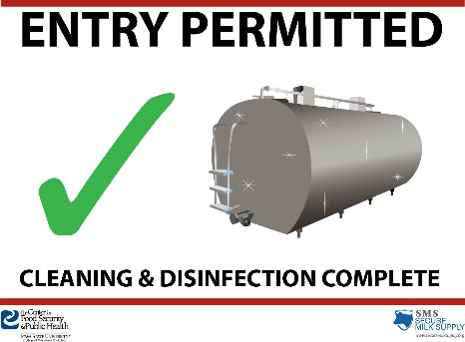
- Apply citric acid solution to areas of the milk house where hauler walked/touched
- Allow the citric acid to contact the surfaces for 15 minutes (start time upon first application) to inactivate the virus.
  - Solution must remain ‘wet’ to actively work; reapplication may be necessary.
- After contact time has passed, switch signs on glass doors to: Entry Permitted; Cleaning and Disinfection Complete (English and Spanish)
- If protective outerwear and footwear is soiled, wash with water to remove visible contamination
- Disinfect protective outerwear and footwear, allowing 15 minutes of contact time on all soiled surfaces
- Remove protective eyewear and boots and store
- Remove gloves and dispose of in milk house garbage

