Premises Name: _______________________________
Premises ID (PIN): Address:_____________________________________

Personnel Entry/Exit: Standard Operating Procedure (SOP)

Example SOP – Modify to fit your operation
Personnel Entry Procedures
- Park vehicle in designated area and walk to (designate farm entrance: building, gate, etc.)
- Personnel should come to work clean, having showered, in clean clothes and footwear (have not been worn around livestock)
- Personnel should have a signed Employee and Visitor Arrival Agreement on file
  - www.securemilksupply.org/Assets/Employee-Visitor-Agreement.pdf
- Personnel should bring a clean set of clothes to change into prior to leaving
- Personnel should cross the line of separation (LOS) at the [DESCRIBE farm entrance: building, gate, etc.]
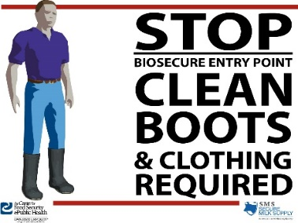
- Personnel should leave footwear, clean set of clothes and all personal items that cannot be cleaned and disinfected in [designated area]
- Animal handlers:
  - Change into farm-dedicated clothing OR wear clean coveralls/protective outerwear
  - Change into farm-dedicated footwear OR disposable or disinfectable footwear
  - Wash hands OR wear gloves
- Non-animal handlers:
  - Change into farm-dedicated footwear OR disposable or disinfectable footwear
  - Wash hands OR wear gloves
  - Avoid direct contact with farm personnel and animals
- Go directly to assigned task

Personnel Exit Procedures
- Personnel should cross the line of separation (LOS) at the [DESCRIBE farm entrance: building, gate, etc.]
- Remove farm dedicated footwear and leave on farm side of the LOS
- Animal handlers:
  - Remove dirty farm clothing and footwear and leave on farm side of LOS OR transport home in sealed garbage bag for laundering
  - Cross the LOS and put on clean clothes and your own footwear
- Non-animal handlers:
  - Remove farm dedicated footwear OR dispose of OR disinfect footwear
  - Cross the LOS and put on your own footwear
- Exit through the Biosecure Entry point
- Go directly to vehicle and leave premises

